**Linear regression Essential term**

The functions mean_absolute_error, mean_squared_error, and r2_score from the sklearn.metrics module are used to evaluate the performance of a regression model. Here's what each one does:

**1. mean_absolute_error (MAE)**

* Measures the **average absolute difference** between actual and predicted values.
* Lower MAE indicates better model performance.

**Formula:**

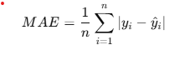

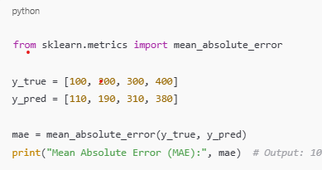

**2. mean_squared_error (MSE)**

* Measures the **average squared difference** between actual and predicted values.
* Squaring the errors penalizes larger errors more than smaller ones.
* **Formula:**

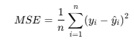

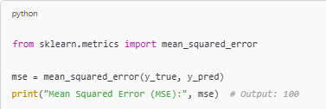

**3. r2_score (R² Score)**

* Measures how well the model explains the **variance** in the target variable.
* Ranges from **0 to 1**, where:
  + **1** = Perfect prediction.
  + **0** = Model performs as badly as predicting the mean.
  + Negative = Worse than a simple mean-based prediction.
* **Formula:**

